**Introduction to git:**

* It is a software configuration management (SCM) or source code management (SCM) tool is used to manage application code.
* Git is a software and it is used to track modification to a source code repository i.e. it maintains the versions of a code developed by developers.
* There are two types of source code management systems:

1) Centralized Version Control System [CVCS]

2) Distributed Version Control System [DVCS]

**1) Centralised Version Control System [CVCS]:**

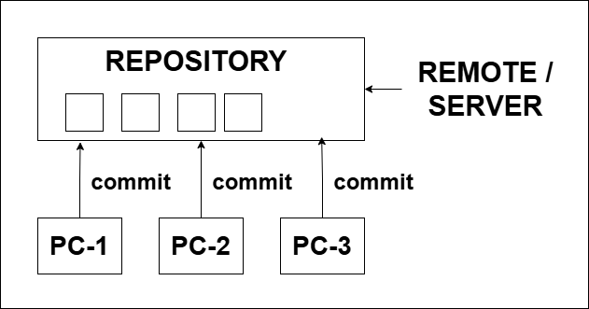

* In centralised version control system code committed by developer are stored in a repository which is placed anywhere or at remote.
* Due to this develops can get what other developers are writing a code.

**Repository:**

* It is a storage or central place in which an aggregation of data is kept and maintained in an organized way.

**Disadvantages of CVCS:**

* It is not locally available means we always need to be connected to a network to perform any action.
* It requires Internet to connect, so it takes time to commit and update the code.
* Since everything is centralized if central server gets failed, we will lose the entire data.

**SUN is the tool used in cvcs.**

**2) Distributed Version Control System [DVCS]:**

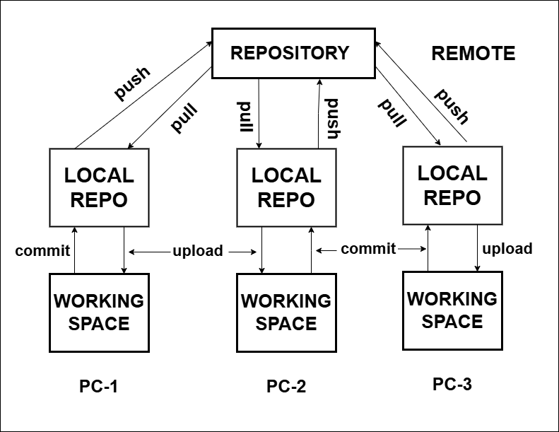

* In DVCS every contributor has a "local copy" or "clone" of the main repository i.e. everyone maintains a local repository of their own, which contain all the files and metadata present in a main repository.

**Difference between CVCS and DVCS:**

|  |  |
| --- | --- |
| **CVCS** | **DVCS** |
| In CVCS, client need to get local copy of source from server. Do the changes and commit those changes to central source on server. | In DVCS, each client can have a local repository as well and have complete history on it. Client needs to push the changes to branch, which will then be pushed to server repository. |
| These systems are easy to learn and set up. | Difficult for beginner’s multiple commands need to remembered. |
| Working on branches difficult in CVCS developer often force merged conflict. | Working on branches is easier in DV C’s developer face less conflict. |
| This system doesn’t provide offline access. | DVCS working fine on offline mode as a client copy the entire repo on their local machine. |
| CVCS list lower as every command need to communicate with server. | DVCS is faster as mostly users deals with local copy without hitting server every time. |
| In CVCS server gets down. Developer can’t work. | If server gets down developer can work using their local copies. |

**What is Git?**

* Git is a original control system used up over tracking changes in compute file.
* It is generally used for source code development in software development.
* Git is a software and it is used to tracking changes in source code.
* The DVCS tool is used for source code management.
* It allows multiple developers to work together.
* It supports non-linear development through its thousands of parallel branches.

**What is GitHub?**

* GitHub is a service not a software.
* It is a provider of Internet hosting for software development and original control using git.
* It offers distributed version control and source code management (SCM) functionality of git, plus its own features.
* It provides access control and several Collaboration Pictures such as bug tracking, feature request, task management, continues integration and wikis for every project.
* It is commonly used to host open-source projects. It is the largest source code post.